**Circuit Diagram & Truth Table:**

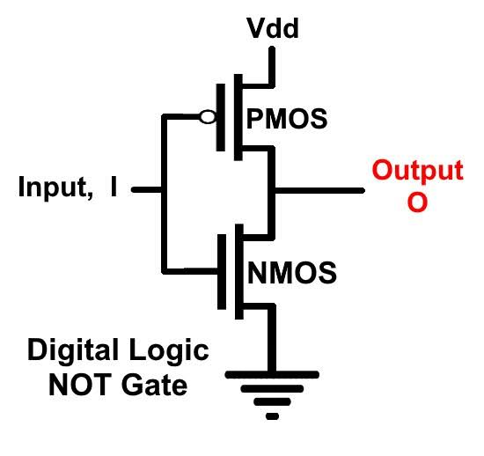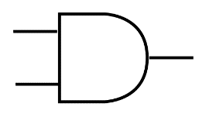 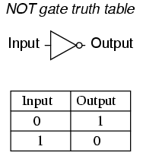

**Code:**

* **Design Module**

module notgate(out,in);

input in;

output out;

supply1 vdd;

supply0 gnd;

pmos p1(out,vdd,in);

nmos n1(out,gnd,in);

endmodule

* **TestBench**

module Baig;

reg in;

wire out;

notgate ng(out,in);

initial

begin

in=1'b0;

#10

in=1'b1;

#10

$finish;

end

endmodule

**Output:**

